**United Software Technology**

**Product Requirement Document (PRD)**

Minimum Viable Product (MVP)

Version 3.0

Prepared By: Tolulope Oluwawemimo

Project Name: HMS🡪 Patient Diagnosis and Clinician Flow, HMO Flow, Wallet Flow

Document Date: 16/02/2024

**Updated version: 20/06/2024**

(All approvals are required. Records of each approver must be maintained)

|  |  |  |  |
| --- | --- | --- | --- |
| Validation Authority | Role | Signature | Date |
| Omoh Sanusi-Aliyu | HOD |  |  |
| Ofuje Stephen Amana | Product Lead |  |  |
| Tolulope Oluwawemimo | Product Manager |  |  |

Summary of Changes:

The document author is authorized to make the following type of changes to the document

without requiring that the document be re-approved:

1. Editorial, Formatting and Spelling

2. Clarification

 To request a change to this document, contact the document author

TABLE OF CONTENT ……………………..

Table of Contents 1

Revision History 1

Document Approver(s): 1

Proposed Feature: 2

1. Introduction 2

1.1 Introduction 3

1.2 Purpose 3

1.3 Intended Audience and Reading Suggestions 3

1.4 Product Scope 3

2. Overall Description 4

Product Perspective 4

Product Goals 4

User Roles and Payment Channels 5

User Stories and Journeys 8

Wireframe Link: <https://miro.com/app/board/uXjVPeFlCYQ=/?share_link_id=601412592904>

**Phase 1**

**PHASE 2; Hospital Management Solution (Doctor Flow )**

On the side menu add a menu and sub-menu as follows

1. List of tables to be added
   1. Facility departments/Units. Must have at least the following columns
      1. Department Name
      2. Specialty/Function/Operation type (Administration, Finance, Patient Case Management)
   2. Hospitals. Holds list of every known existing hospital to which patients can be referred to
      1. Hospital Name
      2. State,
      3. LGA,
      4. Address
   3. Staff table. Already exist but every staff must be link to a department
   4. Laboratory test list
2. Case Management (Menu)
   1. On click display a dialogue box for user to enter patient file number, and Search Button on entering display name for validation. On click display the following tabs
      1. Patient Vitals
      2. Diagnosis
      3. Laboratory
      4. Referrals

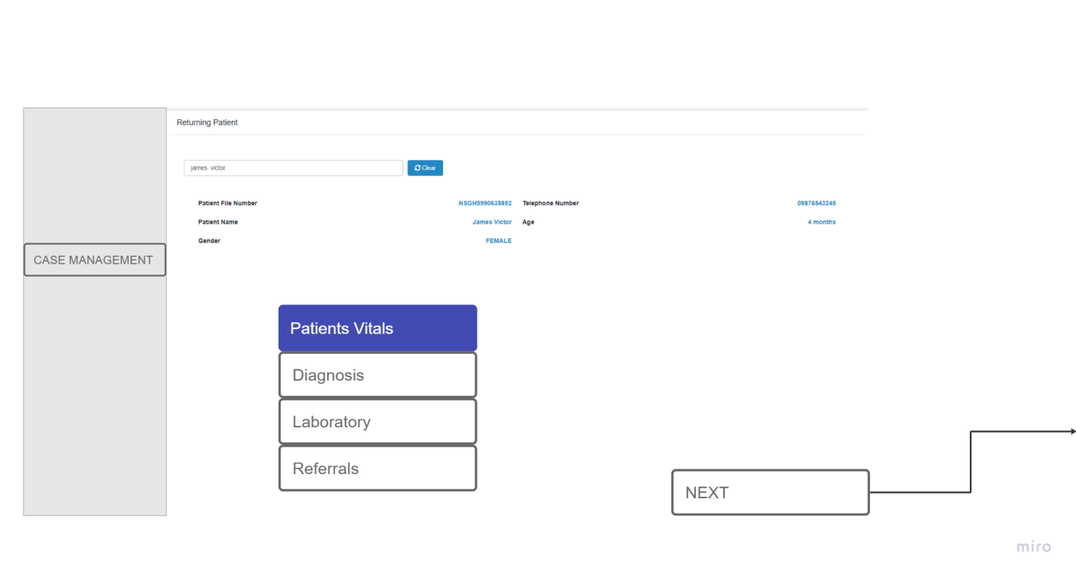

* 1. Patient Vitals; (Give access to Clinician)
     1. On click, display the following requests for the user to enter the patient vitals;
        1. Date
        2. Temperature
        3. Blood Pressure
        4. Oxygen Level
        5. Weight
        6. Height
        7. Save; Save to … and display on the patient information tab

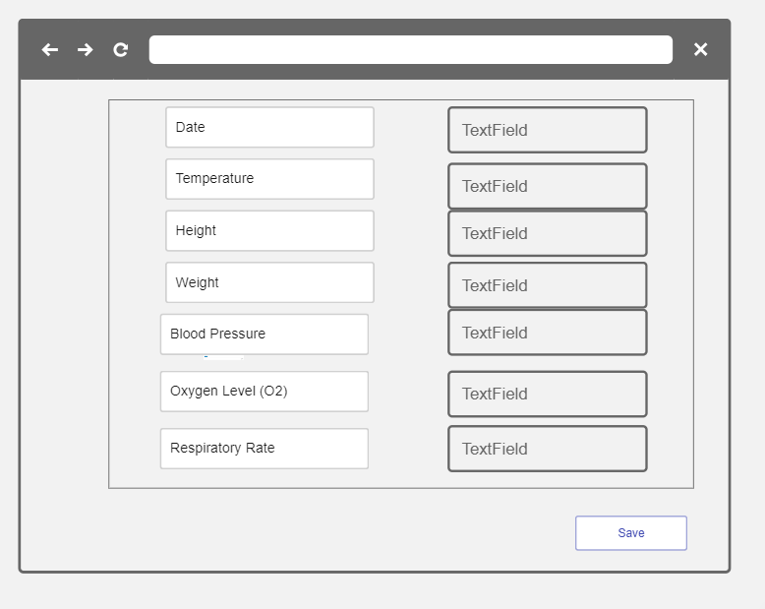

* 1. Patient Diagnosis
     1. On click display dialogue box for user to enter patient file number or Name and search button. On click of Search button,
        1. System checks details of user to be certain that user is classified as clinician.
           1. If No, display message, You cannot have access to patient’s clinical details
           2. If Yes, system checks for the existent of patient.

If not found, display message, Patient detail not found.

If found display Patient details   
See Wireframe ….

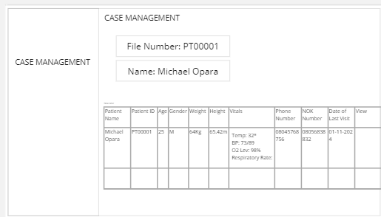

* + - 1. Patient basic Bio Details: Name, Age, Gender
      2. View; On click, View Patient history and engagement detailing the following
         1. Date of engagement
         2. Patient complaint
         3. Clinician interaction and Observation
         4. Case conclusion and conclusion
         5. Recommended Visitation Date
         6. Recommended Tests and Results –View

Display List of tests recommended on the day of visit

View results -- Button – on click display the results uploaded against the test. See wire frame and sample -----

* + - * 1. Clinician Details

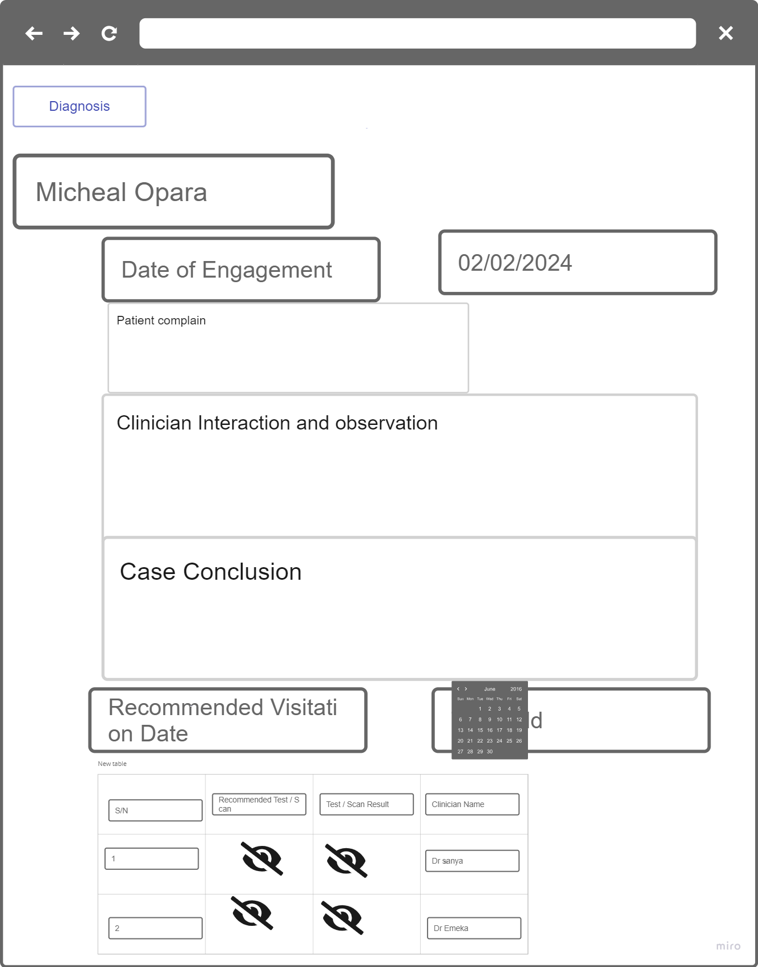

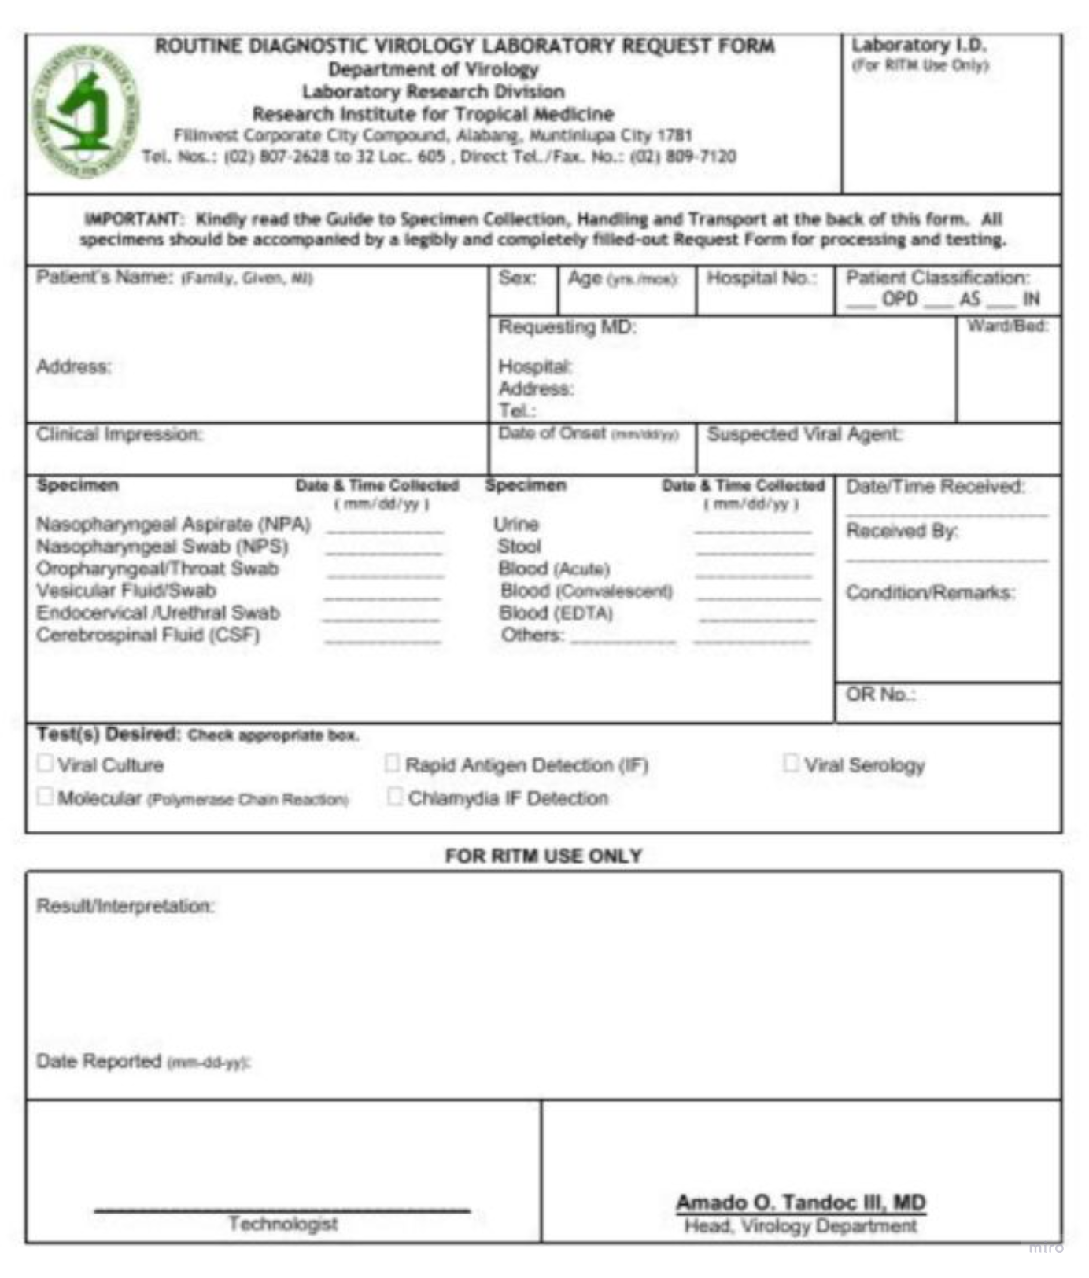Sample Recommended Test/Scan or Test and Scan Result

* + - 1. Documentation section for current visit
         1. Current Patient Complaints --- Text Box
         2. Clinician observation --- Text box
         3. Clinician Recommendation -- Text box
         4. Recommended Tests – Button On Click display dialogue box with the following

Check Box

Name of Test

Recommended Lab

Save button -- on click

save list of tests selected and generate a single unique code or ID for the tests selected. (This will be used to identify the list of tests patient is requested of for a single visit

Navigate user back to the patient case note

* + - * 1. Next Visitation Date -- Calendar
        2. Referral --- Button on click select Internal /External

If Internal is selected display list of facility in the Hospital

If External is selected, display page with

Referral Text Box. To enable user enter referral Note.

list of Hospitals – Only one can be selected

Text box ‘’Other Hospitals’’, to allow user enter hospitals when it is not displayed on the list of hospitals (**This is used to manage referral to hospitals not listed yet)**

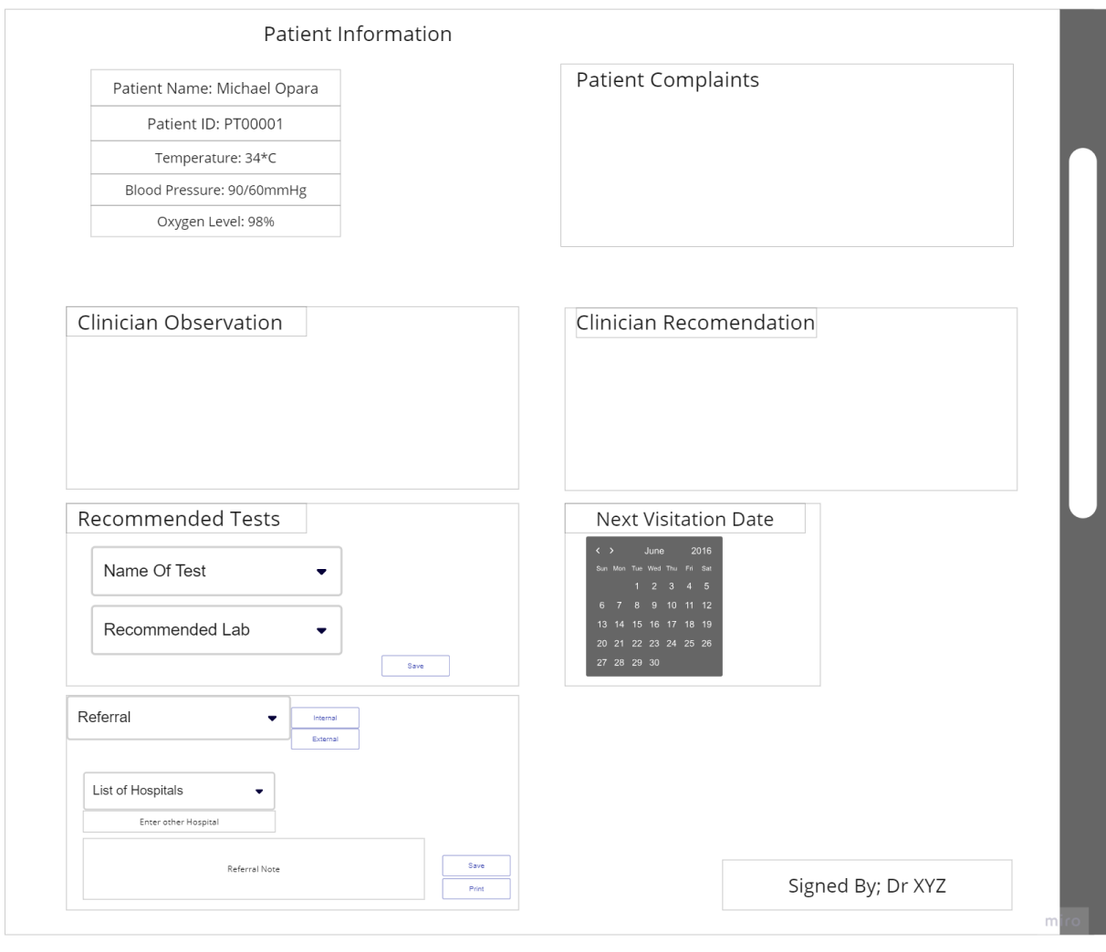

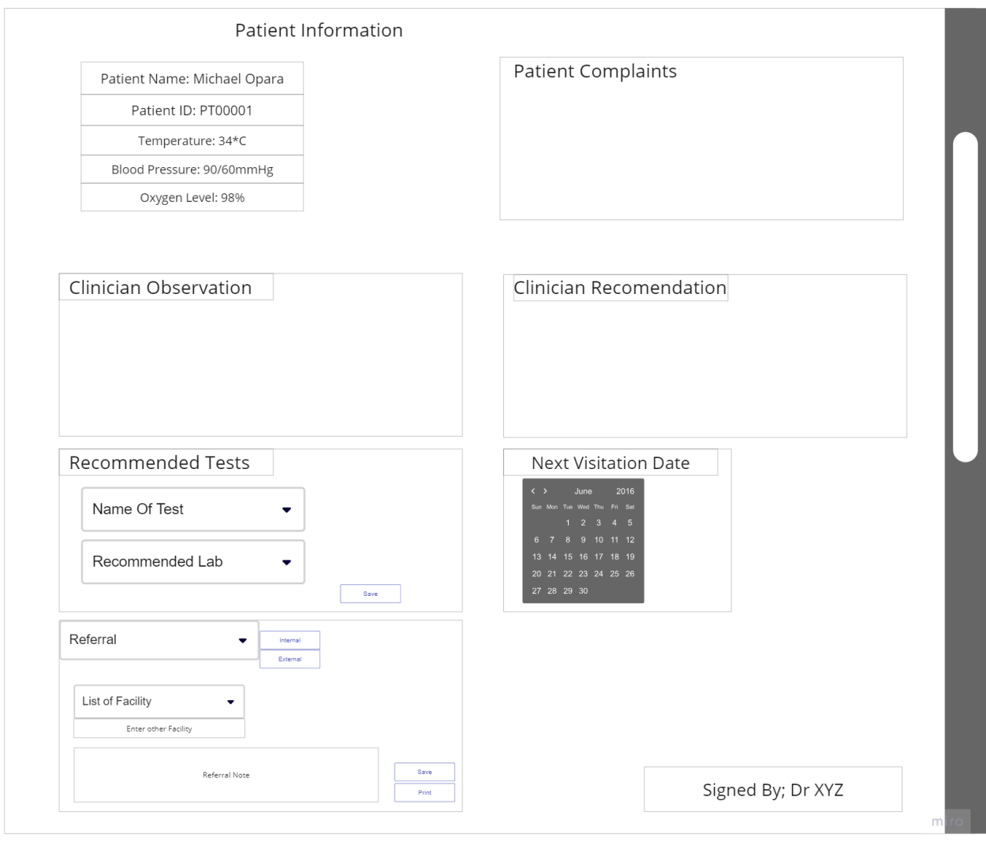

Save Button. On Click Save all entered records and navigate user to continue patient case note

* + - * 1. Save Record. Used to complete patient case documentation. On click, save record and display the following

Print recommended Test. On click display recommended test details on letter head of the hospital and allow Print/generation of PDF.

Print Referrals: On click print referral detail entered during documentation on the facility’s letter head. It should contain the following

Date of referral

Referral documentation entered by the doctor

Detail of Clinician that prepared the referral.

See sample ….

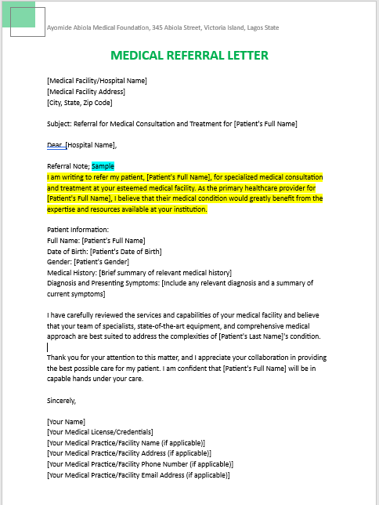

* 1. Laboratory Sub Menu (only accessible to laboratory officials)

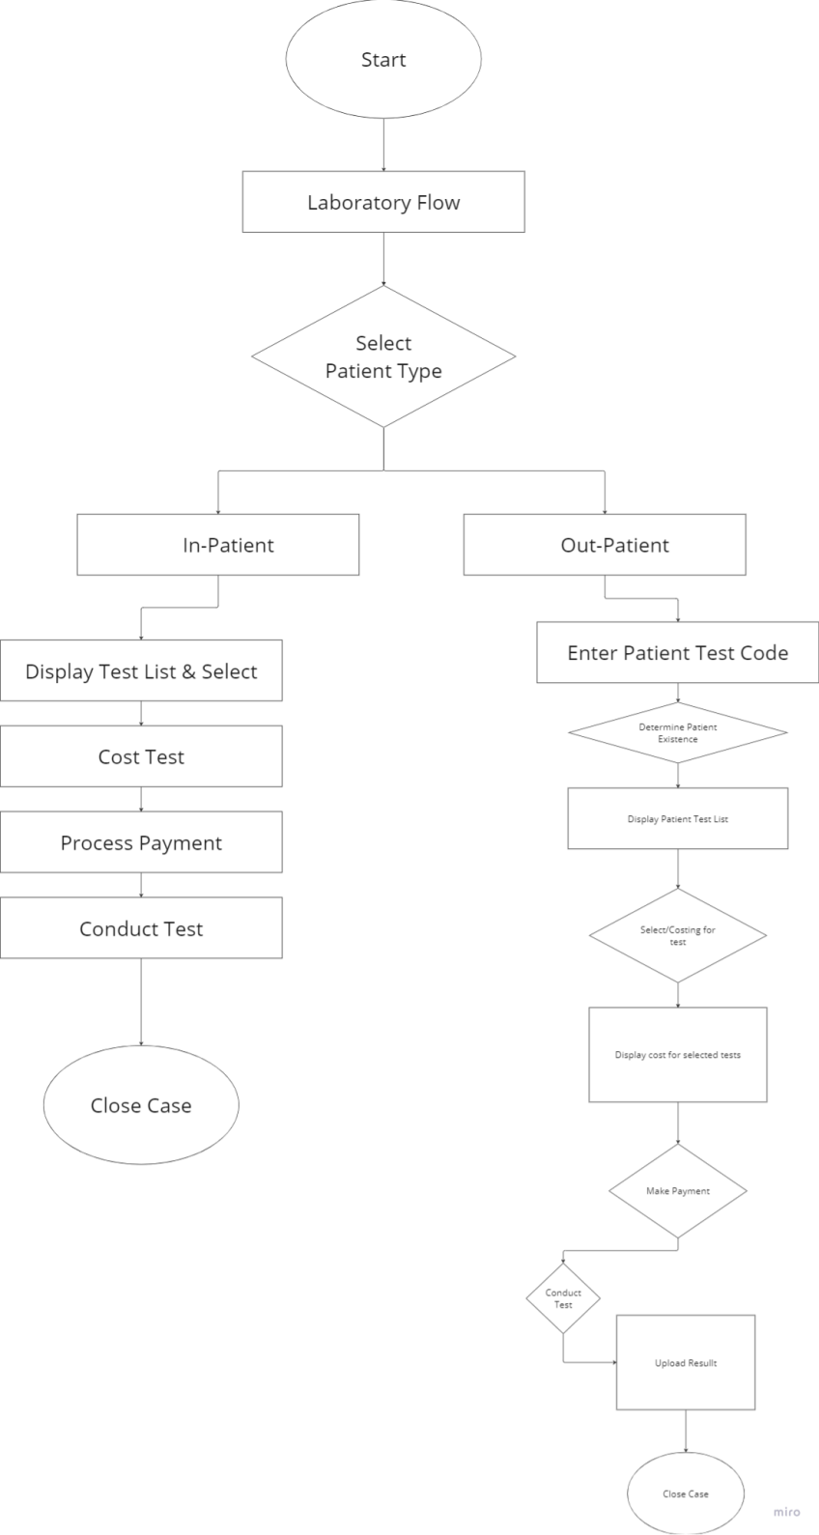

* + 1. On click display dialogue box for user to select if patient is Out Patient or In Patient --- See wireframe ….

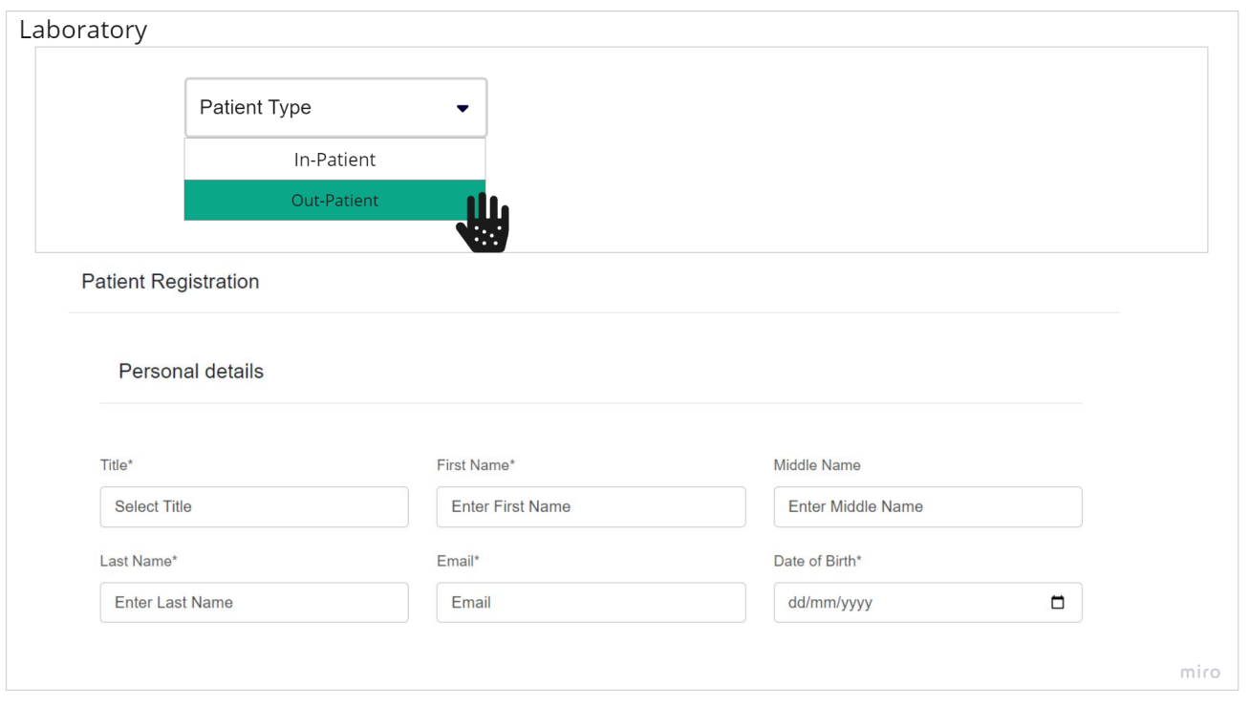

* + 1. If Out-Patient is selected, display page to
       1. enter patient’s basic details using ‘’New Patient Registration Template’’ as it currently exists and save patient details
       2. Proceed to process cost of the list of test patient intends to conduct using the test pricing table as it currently exist
       3. notify patient of cost and advice/Process payment.
       4. Test status is set to Payment Advise
       5. After payment set status to Paid
       6. conduct test and change Status to Concluded.

See wireframe ….

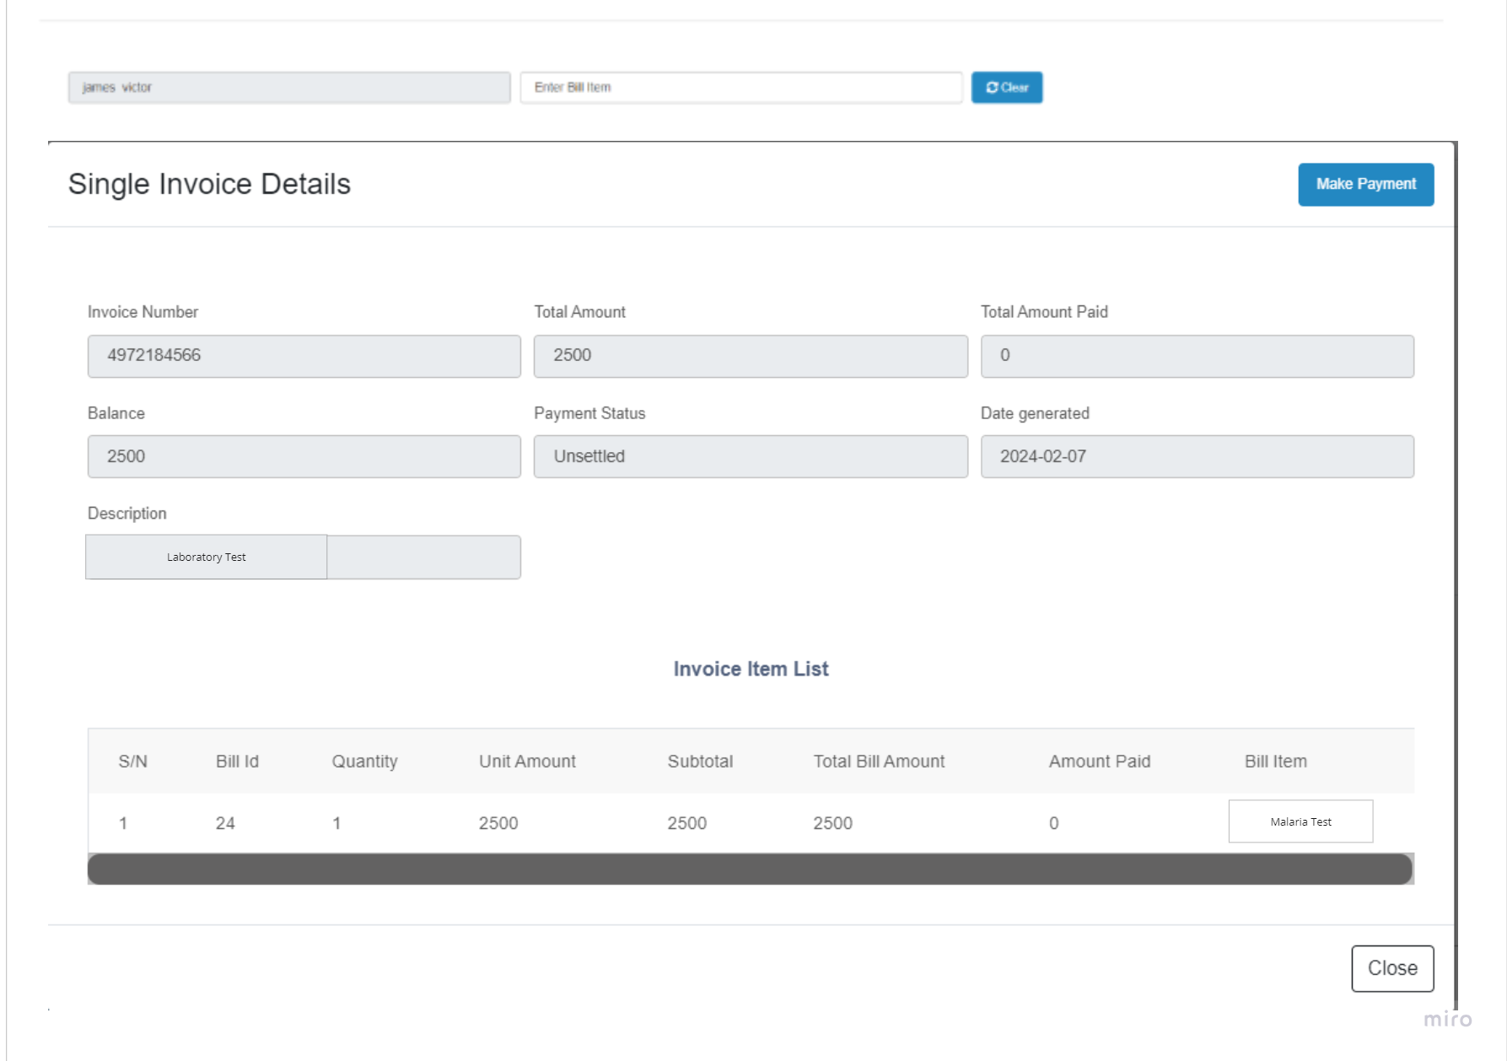

* + 1. If In-Patient is selected, display
       1. On click display dialogue box for user to enter patient file number or Laboratory test Code issued to the patient. On click of Search button,
       2. System checks details of user to be certain that user is classified as Laboratory Clinician.
          1. If No, display message, You cannot have access to patient’s Laboratory details
          2. If Yes, system checks for the existent of patient.

If not found, display message, Patient detail not found.

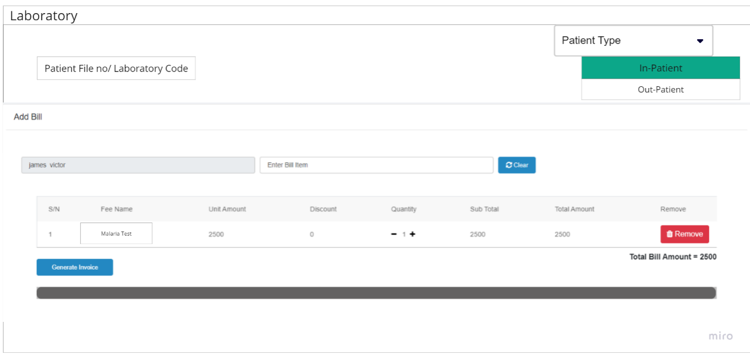If found display Patient details   
See Wireframe …..

Display list of test patient is advised to conduct

process cost of the list of test patient

notify patient of cost and advice/Process payment.

Click Save and system changes test status to Payment Advise

After successful payment system changes test status to Paid

Conduct test and change and upload result against each test conducted.

Allow for multiple upload against each test on the list

Click save and system changes test Status to Concluded.

Process test costing

Process payment --- **See wireframe…….**



Conduct Test and upload result

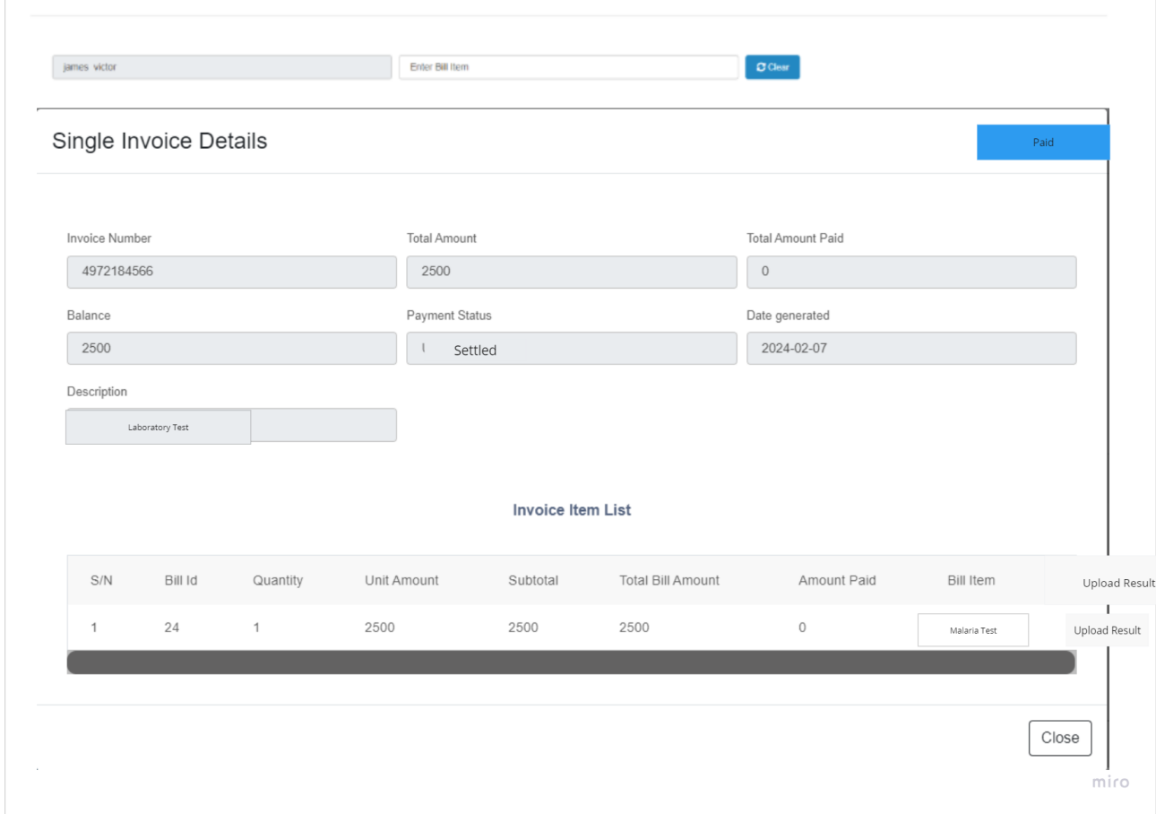

**Patient Result /Prescription**

After the test has been conducted, the Clinician should be able to

1. Upload Patient test result
2. Enter prescription for patient if required
3. System should display the summary of the test and user should be able to download or print

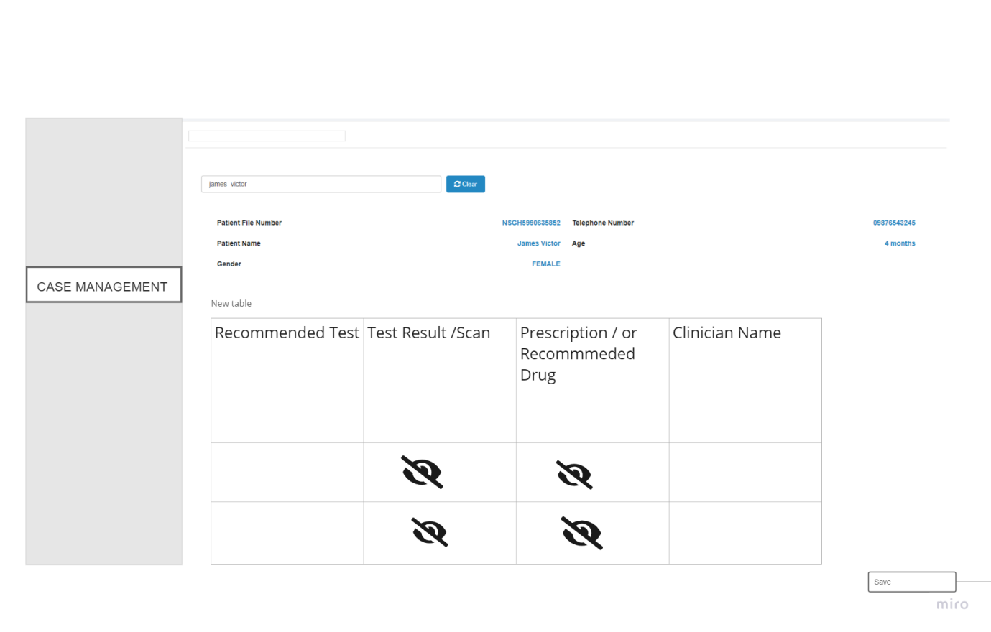

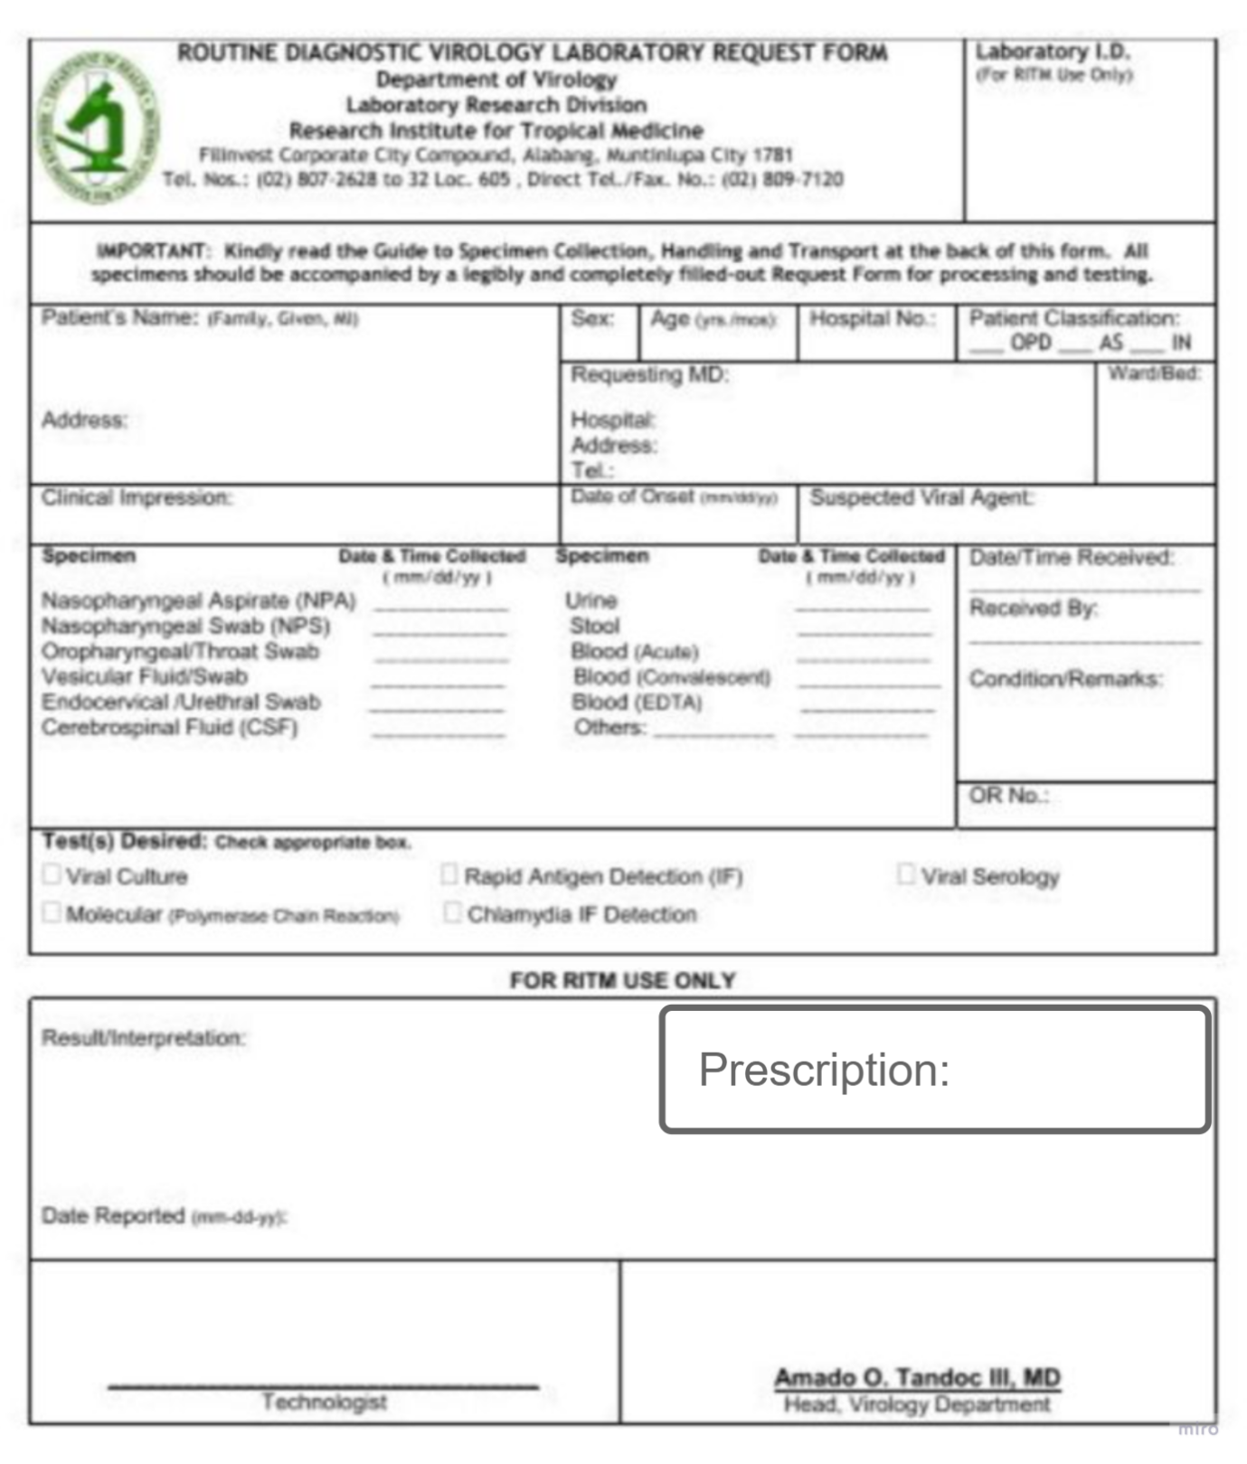

**Phase 2**

**PHASE 2🡪 Update and Observation on HMS (Patient Case Management)**

1. **Create the following Users in the system** 
   1. **Nurse**
   2. **Pharmacy**
2. **User story** 
   1. **For Nurse:** 
      1. **Should be able to conduct patient Vitals**
      2. **Should be able to view patient schedules**
      3. **Should be able to view patient Ongoing Consultation**
      4. **Should be able to see Pharmacy prescription details for patient consultation**
      5. **Should be able to see medical Test details for patient Consultation**
   2. **For Pharmacist:** 
      1. **Should be able to prescribe medication**
      2. **Should be able to generate bills for patient medication**
      3. **Should be able to view prescription history**
   3. **(Existing Flow) For Doctor:** 
      1. **Should be able to view Today’s consultation only**
      2. **Should be able to view patient medical history on click of view from consultation page**
      3. **Should be able to recommend Medical test or Refer to Pharmacy**
      4. **Should be able to schedule consultation**
      5. **Should be able to refer patient to internal unit/external hospital**
      6. **Should be able to reschedule date for patient**
   4. **(Existing Flow) For Laboratory Attendant** 
      1. **Should be able conduct test and upload test result**
      2. **Should be able to generate bill for patient medical Test**
      3. **Should be able to save and edit test**
      4. **Should be able to save and send medical test to Doctor**
3. **User journey for Nurse:** 
   1. Replicate the flow of Receptionist for Nurse flow
   2. Add ‘’Patient Schedule’’ to the side menu
      1. On click, system should display the patient that has been scheduled for consultations (Table Format)
      2. The following details should display
         1. Patient File Number
         2. Patient Name
         3. Schedule date
         4. Doctor Name
      3. User should be able to search with a date range
      4. User should be able to search with the Patient name and File Number
   3. Create a consultation menu for the Nurse (replicate consultation details)
      1. On click of consultation system should display the following (see wireframe)

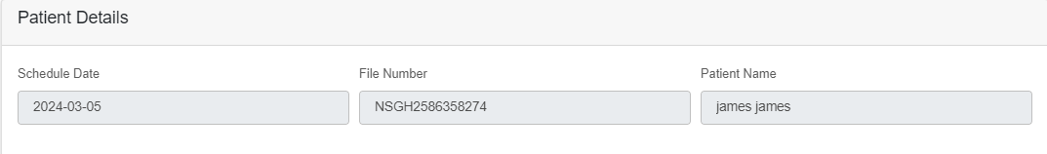

|  |
| --- |
| Medical History |
|  |

|  |  |  |  |
| --- | --- | --- | --- |
| Date | Doctor Comment | Doctor Name | Action |
| 01/02/2021 | Diabetes treatment | Dr Lolo | View |
| 05/06/2022 | Blood Sugar | Dr kaffy | View |
| 01/09/2023 | Abdominal Pain | Dr brand | View |

Consultation Today (23/05/2024)

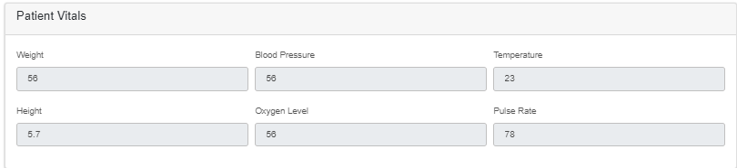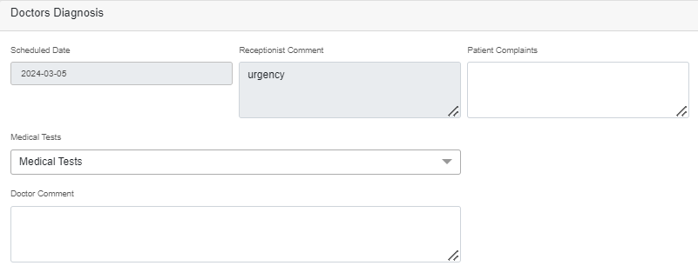

Consultation Status

Treatment

Doctor diagnosis

Refer to pharmacy

Schedule Medical test 

Pharmacy Note

Re schedule date

Refer Patient

Close Case

Schedule Consultation

1. Receptionist role
   1. Add ‘’Patient Schedule’’ to the side menu
      1. On click system should display the patient that has been scheduled for consultations (Table Format)
      2. The following details should display
         1. Patient File Number
         2. Patient Name
         3. Schedule date
         4. Doctor Name
      3. User should be able to search with date range
      4. User should be able to search with Patient name and File Number
   2. Remove consult doctor button from the search page
   3. 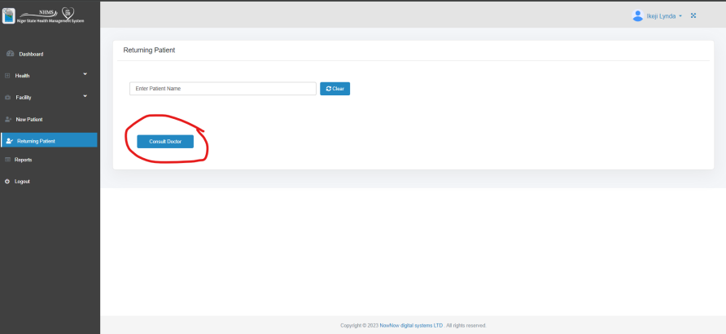
2. Doctor Role
   1. Create a “Consultation History” and add it to the side menu after consultation menu 🡪 this will display all consultations addressed to the selected Doctor
      1. Add a date range box to search by date FROM -🡪TO
   2. User should be able to search by name or patient file number🡪 1
   3. Update consultation menu -🡪 ‘’Today’s consultation’’
      1. It is only patient referred to the doctor for that day that should display on the consultation page.
      2. Add status column ( Pending, Ongoing, Closed) (LOV) 🡪3

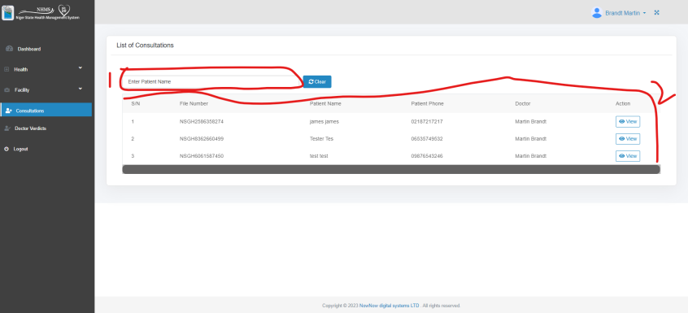

1. Refer Patient
   1. System should display selection for the following:
      1. Internal
         1. If internal is selected system should auto display the facility
         2. System should display the facility department
      2. External
         1. If external is selected system should display a drop-down list of facility and also allow user to create/ enter a new facility
         2. System should not Display Department list
   2. 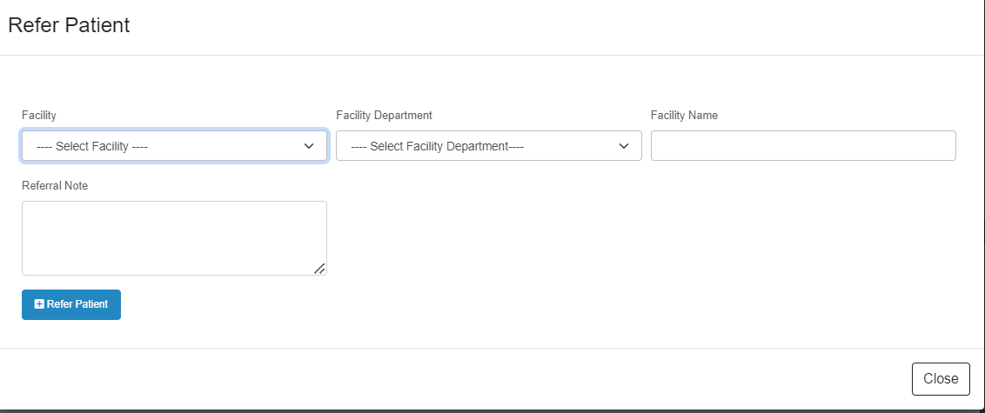
2. Consultation🡪 view 🡪 consultation details
   1. On click should display the previous patient history and the current day consultation🡪 (see sample design below)
   2. On click of view of a selected date, system display a modal to view the Medical history details



|  |
| --- |
| Medical History |
|  |

|  |  |  |  |
| --- | --- | --- | --- |
| Date | Doctor Comment | Doctor Name | Action |
| 01/02/2021 | Diabetes treatment | Dr Lolo | View |
| 05/06/2022 | Blood Sugar | Dr kaffy | View |
| 01/09/2023 | Abdominal Pain | Dr brand | View |

Consultation Today (23/05/2024)



Refer to pharmacy

Schedule Medical test 

Pharmacy Note

Re schedule date

Refer Patient

Close Case

Schedule Consultation

* 1. See wireframe for medical history view



|  |  |  |  |  |  |  |  |
| --- | --- | --- | --- | --- | --- | --- | --- |
| Medication | Administration Mode (LOV) | Quantity | Dosage | Measurement (LOV) kg, mg, g, mils | Number of times per/day () | Start date | End date |
| Lonart | Medication | Auto fill | 2mg |  | 2 | 24/05 | 30/05 |
| Drip | Injection | Auto fill |  |  |  | 26/05 | 28/05 |

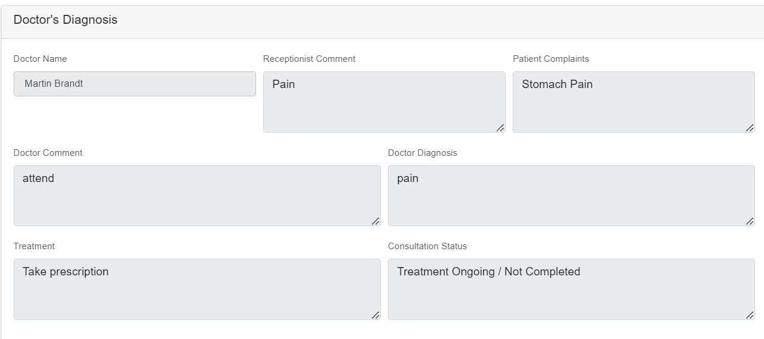

* 1. Add pharmacy note to the consultation details page
     1. User should be able to enter Pharmacy note for referral to pharmacy
     2. Add ‘’refer to pharmacy’’ button beneath the pharmacy note
        1. On click of “Refer to Pharmacy button’’, System should display a dialogue box for user to enter pharmacy Note
        2. Click on save display the patient details and make available for other users.
  2. On medical test dialogue box
     1. User should be able to select one or multiple medical test to make ‘’Schedule medical test’’ button active
     2. Add a ‘’Schedule medical test button ‘’
        1. On Click of schedule medical button, , System should display a dialogue box for user to select medical test
        2. Click on save display the patient details and make available for other users.
  3. Add Close Case button to the consultation page
     1. System should Make Close Case Active If no pharmacy note or medical lab test is selected.
  4. Add Download IMG/Video column to the medical test table
     1. User should be able to view on click of the Image/Video
  5. Add Schedule consultation button to the page
     1. On click should send the details to patient schedule list and save to consultation page
  6. Refer patient: Change the refer patient button to the bottom left
  7. Add re-schedule date box under schedule date

1. Doctor verdict 🡪 Remove Doctor Verdict menu and page
   * 1. 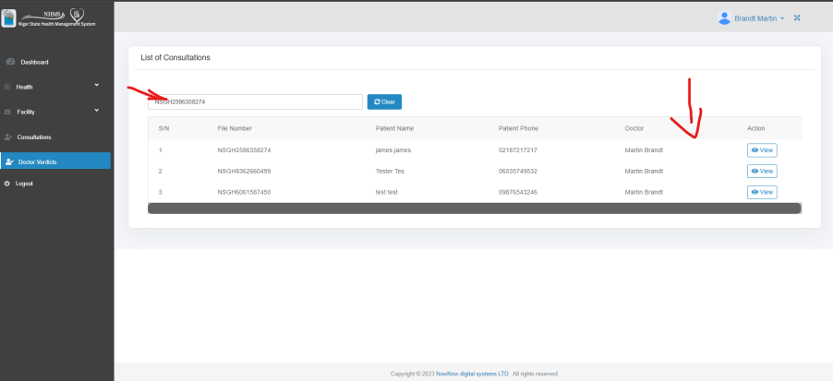
2. Lab attendant
   1. User should be able to search patient by name or file number
      1. User should be able to enter file number to search

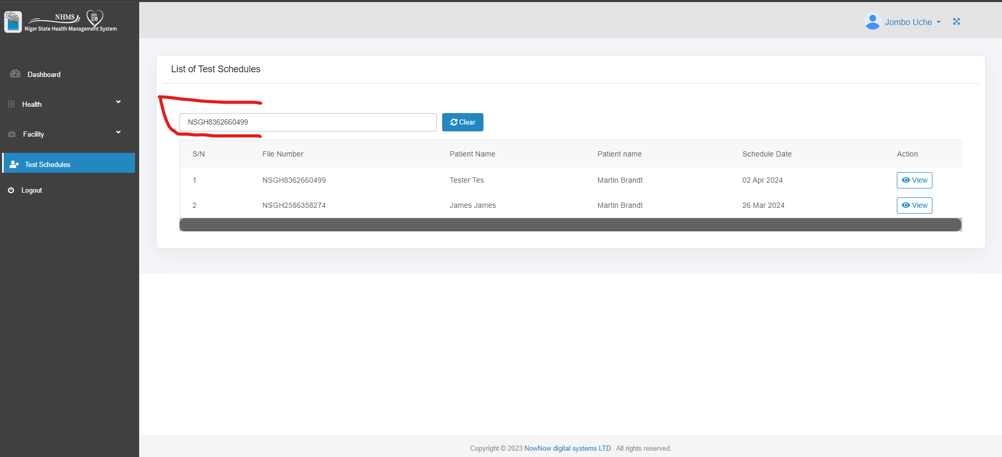

1. Lab attendant 🡪 click on view
   1. Add select box beside test name for user to select
   2. Add summation of bill selected and display at the bottom page
   3. Add Submit button at the bottom right

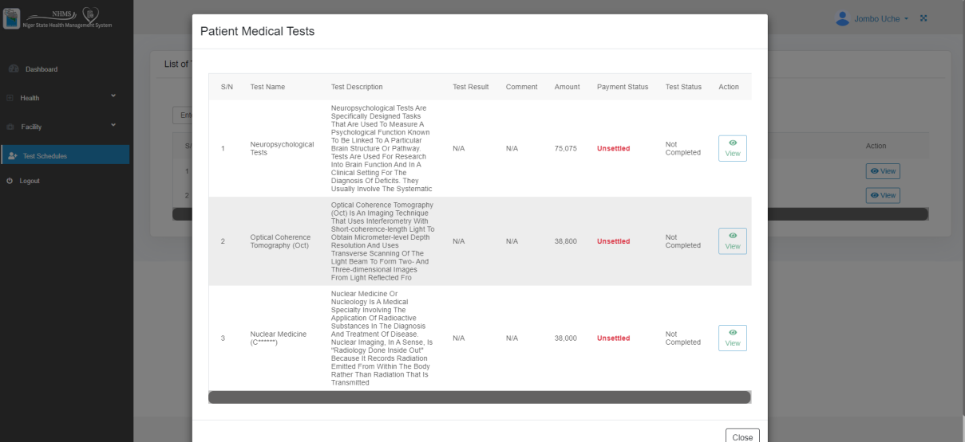

Total summary

Submit

* 1. On click of ‘’submit button’’, bill details are sent to the billing officer and patient is refer to billing officer to make payment
     1. Billing officer should be able to add all bills for patient to make payment
     2. Payment status should change to paid on click of Make Payment and payment has been confirmed successful by CBS
  2. Create upload box for lab attendant to upload IMG/Video of test/scan
     1. User can upload more than one file
     2. User can delete upload file
  3. Save
     1. On click on save, details are saved and editable within the Medical Test
  4. Save and Submit
     1. On click of Save and Submit, the details is saved and cannot be edited
     2. Details are sent to consultation page

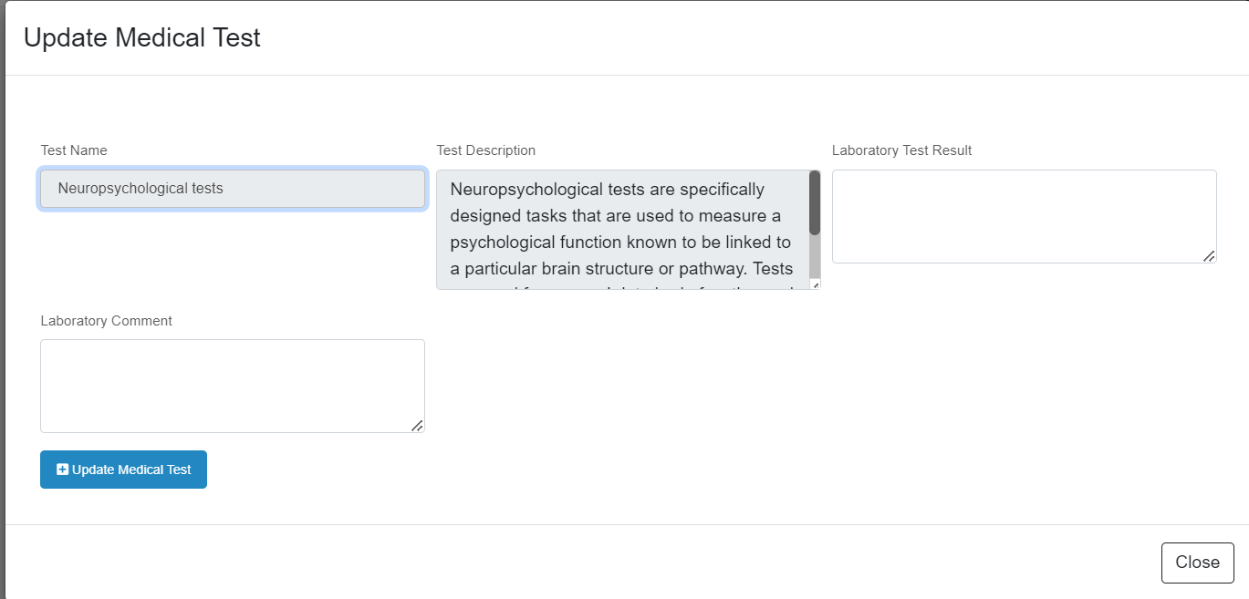

Save & Submit

Save

File2

File 3

Delete

Delete

File 1

Upload

Delete

1. Create a user role for “ **PHARMACY ATTENDANT**”
   1. Replicate the lab attendant flow



* 1. On click of view system should display the following (See wireframe )

Pharmacy Note

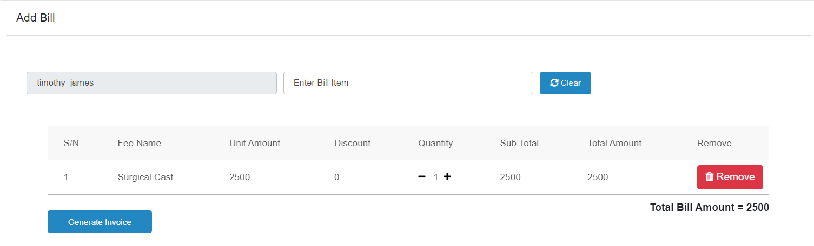

View

* 1. The details to display (Table Format)
     1. Pharmacy Note
     2. Prescription (Bill item) (LOV)
     3. Fee name
     4. Unit Amount
     5. Discount
     6. Quantity
     7. Sub total
     8. Total Amount
     9. Amount
     10. Remove
     11. Generate Invoice button at the bottom of the table
         1. On click of Generate Invoice (system generates the details to the billing officer to add all billings and for patient to make payment)
            1. Payment status should change to paid on click of make

Payment

* + - * 1. On successful payment to CBS, system should send the receipt of Bill items paid for to Pharmacist
    1. View
       1. On click of View, system should display the following
       2. Prescription (Bill item) (LOV)
       3. Quantity
       4. Amount
       5. Payment Status
       6. Prescription Status
       7. Prescribe Button
          1. system should make active only if payment status is showing Paid
          2. System should make Active if Prescription Status is NO
          3. System should make In active if Prescription Status is YES
       8. View Prescribe Button
          1. User can only view Prescription History and not editable
          2. System Should make ACTIVE only if Prescription Status display YES
       9. Save and proceed
          1. On click of ‘’Save and Proceed button’’ System should display the details on consultation page.
  1. On click of View, system should display the following (see Wireframe)

|  |  |  |  |  |  |
| --- | --- | --- | --- | --- | --- |
| Prescription Item | Quantity | Amount | Payment Status | Prescription Status |  |
| LONART | 2 | 3000 | PAID | Yes |  |
| AUG | 2 |  | PAID | YES |  |
| DRIP | 1 |  | PAID | yes |  |
| PARACETAMOL |  |  | PAID | Yes |  |
| BLOOD TONIC |  |  | PAID | Yes |  |

View Prescription

Precsribe

|  |  |  |  |  |  |  |  |
| --- | --- | --- | --- | --- | --- | --- | --- |
| Medication | Administration Mode (LOV) | Quantity | Dosage | Measurement (LOV) kg, mg, g, mils | Number of times per/day () | Start date | End date |
| Lonart | Medication | Auto fill | 2mg |  | 2 | 24/05 | 30/05 |
| AUG | Medication | Auto fill | 2cap |  | 1 |  |  |
| DRIP | Injection | Auto fill | 1pint |  | 3 |  |  |
| PARACETAMOL | Medication | Auto fill | 2tb |  | 5 |  |  |
| BLOOD TONIC | Medication | Auto fill | 2tb |  | 5 |  |  |

Save and proceed

Phase 3

HMO FLOW

1. Acceptance Criteria:
   1. HMO systems integrate with hospital Management systems (HMS) to synchronize patient data.
   2. APIs and Secure Connections: Use APIs to establish secure connections for real-time data exchange.
   3. Pre-Authorization Request: The hospital must submit a pre-authorization request to the HMO for certain treatments.
   4. Approval Workflow: The HMO reviews the request, checks the medical necessity and coverage, then approves or denies it
   5. Notification: The hospital is notified of the decision through the HMS Portal
   6. CLAIMS: The hospital generates a claim using the documented service data after service delivery.
   7. Claim Details: Include patient details, Approval codes, costs, and pre-authorization references.
   8. The claim is submitted electronically to the HMO via Secure channel
2. Admin Users:
   1. Receptionist
   2. Billing Officer
3. Features Menu
   1. New patient
   2. Existing patient
   3. Bill
   4. Claims (Add)
4. User Story
   1. Receptionist
      1. As a user I should be able to verify HMO user
      2. As a user I should be able to send In-App Mail and receive notification
      3. As a user I should be able to Register HMO user
   2. Billing officer
      1. As a user, I should be able to send requests for billing approval
      2. As a user I should be able to send In-App Mail and receive notification
      3. As a user I should be able to view claims details
      4. As a user I should be able to send claim requests and receive notification
5. User Journey
   1. Receptionist
      1. On click of New Patient system should display the onboarding form for the user to select the following
         1. HMO Provider (List of Value)
         2. HMO ID (enter)
         3. Verify button
            1. On click system should call the HMO API and display the response

If yes, system should prefill the details in the field

User should be able to enter the details left for the patient to be registered

If no, system should display an error message, user does not exist

* + - 1. Send HMO Mail button
         1. On click should send mail to HMO which includes the patient details
         2. System should display the response in the In-App notification

If yes, User should be able to enter the details and click on register

If no, system should display the error message sent in the notification response

* + - 1. Notification
         1. To receive In-app mail

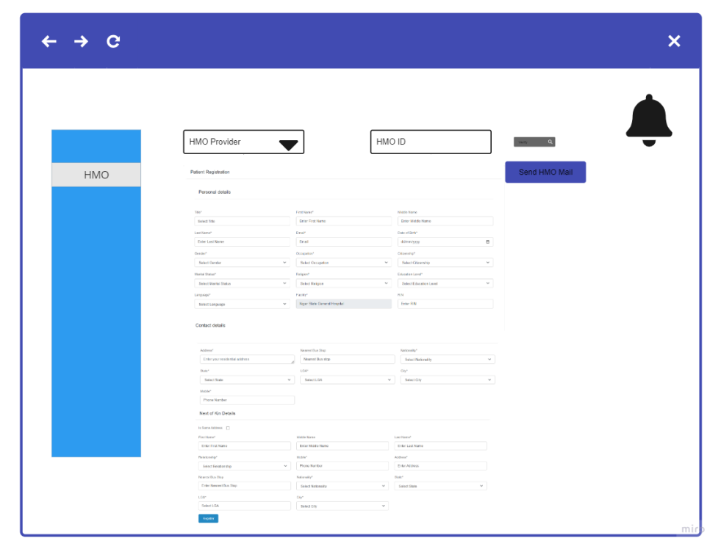

* + 1. On click of existing patient, system should display the page to search for the HMO user by the following
       - 1. Name
         2. File Number (generated when registered)

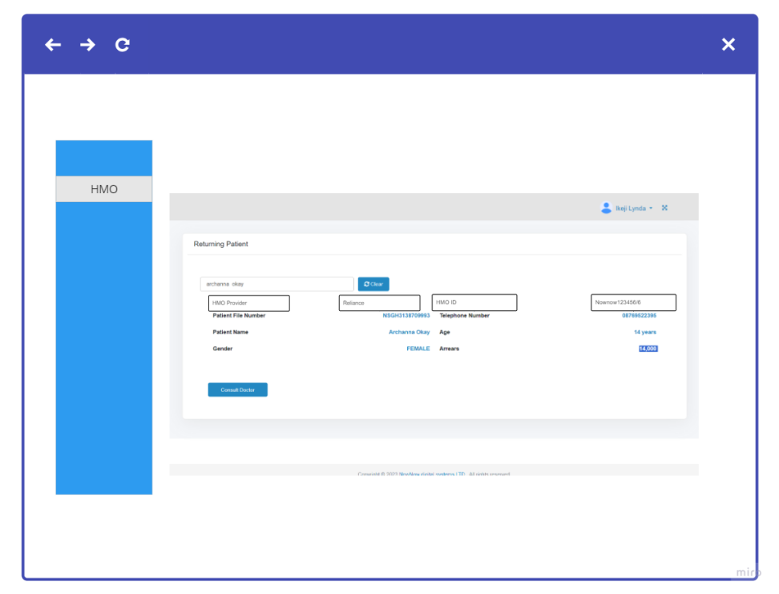

* 1. Billing Officer
     1. On click of ‘Bill’ system should display the page for user to search HMO patient by
        1. Name
        2. File number
     2. On search system should display the billing details of the patient

Note: This is to modify the existing billing flow

* + 1. 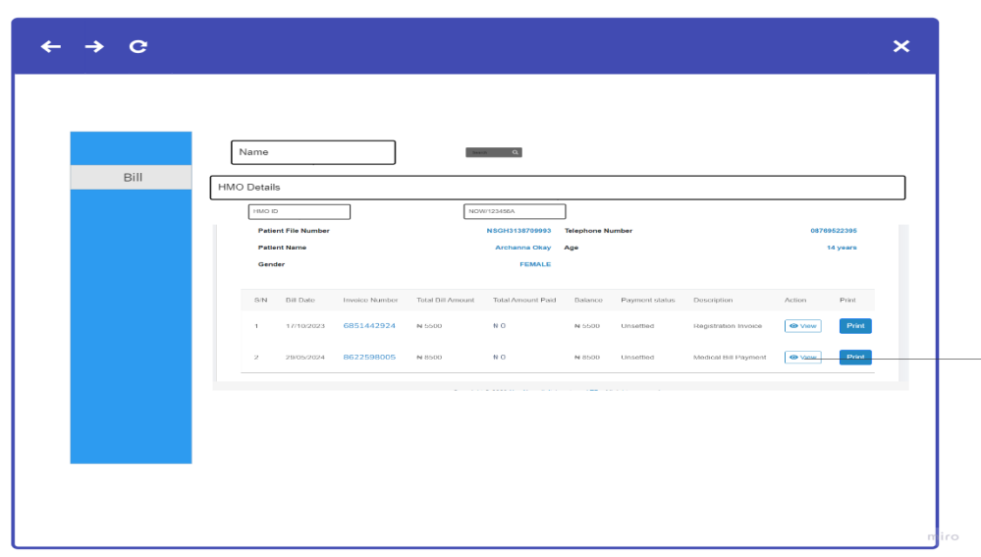
    2. On click of View, system displays the bill details of the selected bill
       1. Patient details
       2. Invoice details list (in table)
       3. Send HMO Mail Button
          1. On click system should display mail format for user to send to the HMO provider

1. Patient HMO ID

2. Treatment

3. Bill items

4. And other relevant details

* + - 1. Send HMO Request Button
         1. On Click, system sends request details to HMO Provider with the following

1. Patient HMO ID

2. Treatment

3. Bill items

4. And other relevant details

* + - 1. Notification
         1. To receive In-app mail/ message
      2. Make Payment Button
         1. On click of ‘Make Payment’, system should display the following

Pay Via HMO

Patient pays

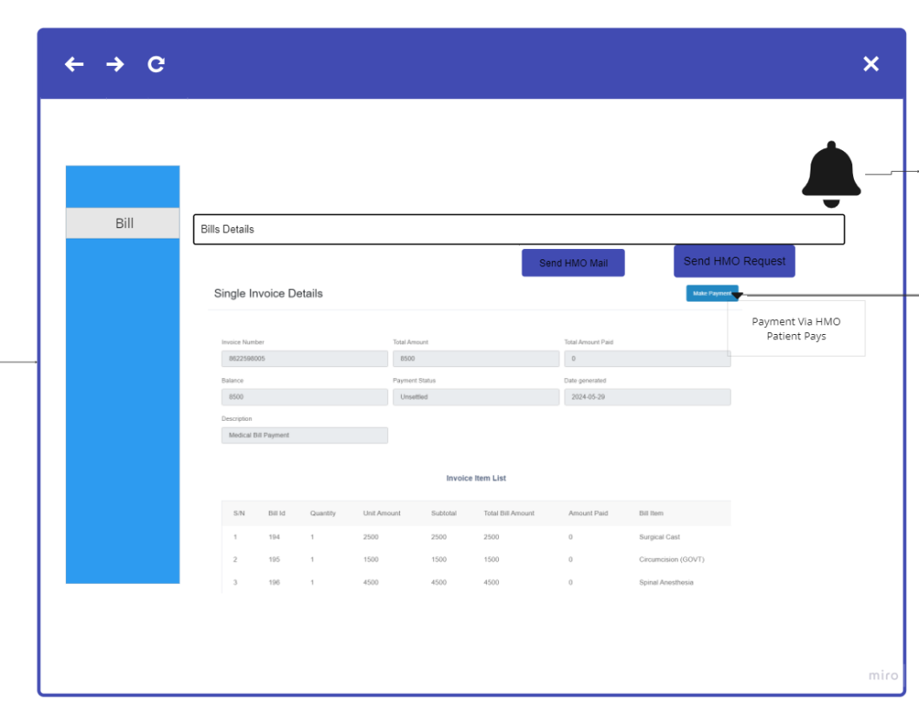

* + 1. On click of Pay via HMO, System should display the following
       1. Total due balance
       2. Bill item
       3. Amount Assessed
       4. Payment Type (LOV) (ADD Field)
          1. HMO %
          2. HMO full amount
          3. HMO part amount
          4. No Coverage
       5. HMO % (ADD Field)(Input box)
       6. HMO amount (ADD Field) (Input Box )
          1. If payment type selected at point 4 above is HMO %

Not Editable

Auto compute amount assessed which is equal to Point 5(HMO %) multiplied by Point 3 (amount assessed)

* + - * 1. If payment type selected at point 4 above is HMO full payment

Not Editable

Display amount assessed for the HMO amount field

* + - * 1. If payment type selected at point 4 above is HMO part payment

Editable

User should be able to enter an amount not greater than the assessed amount

* + - * 1. If payment type selected at point 4 above is No Coverage

Not Editable

Amount equal to zero

* + - 1. Patient Amount (ADD Field) (Input Box)
         1. Editable
         2. User cannot enter an amount greater than assessed amount minus HMO amount
      2. Total
         1. System should sum the HMO amount
         2. System should sum the patient amount
      3. Process HMO payment (Add Field)
         1. On click

Navigate user to approval page

Approval ID

User to upload the approval evidence

Save. On click

system settles the HMO bills

System indicates settlement type equal to HMO

the system sends it to the claim table

* + - 1. Patient Pay Button
         1. Only Active if

‘HMO payment ’ has payment status Settled

Only if patient amount to pay is greater than 0

System should direct the user to a payment gateway for the settlement of bills

On successful response, system should change payment status to paid.

If not successful, system should display an error message

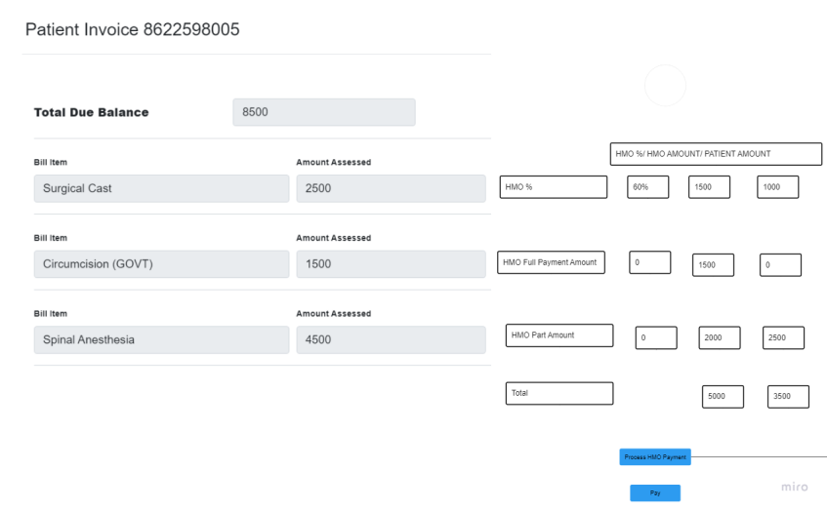

* + 1. On click of ‘Patient pays ’ the following should display
       1. Wallet Balance
       2. Total due balance
       3. Bill item
       4. Amount Assessed
       5. Amount to pay
       6. Pay button (LOV)
          1. On click system should display

Pay via bank

Pay via wallet

On click system should check if the amount in the wallet is sufficient

If sufficient, system should deduct from the patient's wallet and display successful

System indicates settlement type equal to Wallet

If not sufficient, system should notify the user, of insufficient balance and direct to make payment via bank.

* + 1. On click of ‘pay Via Bank’: This Flow already exists

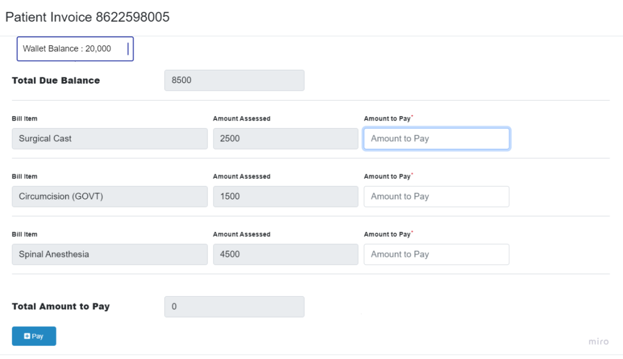

* 1. Claims
     1. On Click, system should display the HMO Claims details as follows in a table format
        + 1. Provider ID
          2. Provider Name
          3. Total Claim Amount
          4. Pending Amount
          5. View button
          6. On click of View system should display the following

Patient HMO ID

Patient Name

Amount

Claim Status

Approval Note

Claim request form (edit/view)

On click system should display a form for a user to fill in the necessary details

Send Email button

User should be able to send email from the In-App with a page format including the form details

Claim button

Make ACTIVE only if the selected Claim status is showing (pending or denied)

On click, system should send the request to the HMO Provider

Notification

The user receives a message in the notification box sent by the HMO provider.

* 1. Claims Settlement and Reconciliation
     1. System should display all claims lists
        1. HMO Provider
        2. HMO Provider ID
        3. Reference No
        4. Check box
        5. Settle Claims
           1. On click a dialogue box should display for a user to enter claim evidence for the schedule

Transaction Reference no

Amount Paid

Upload File box

Settle Button

On click should display paid on bill page

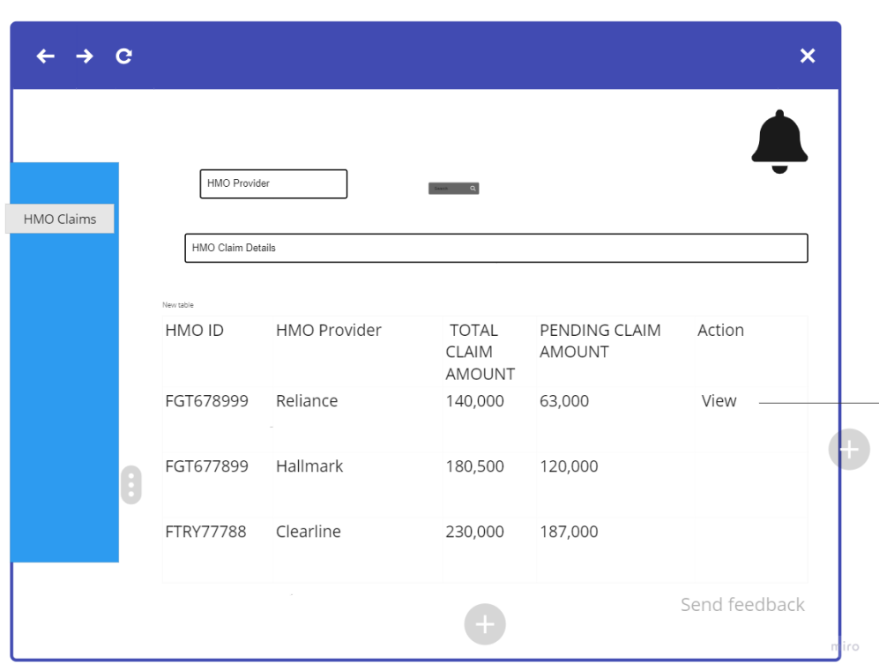

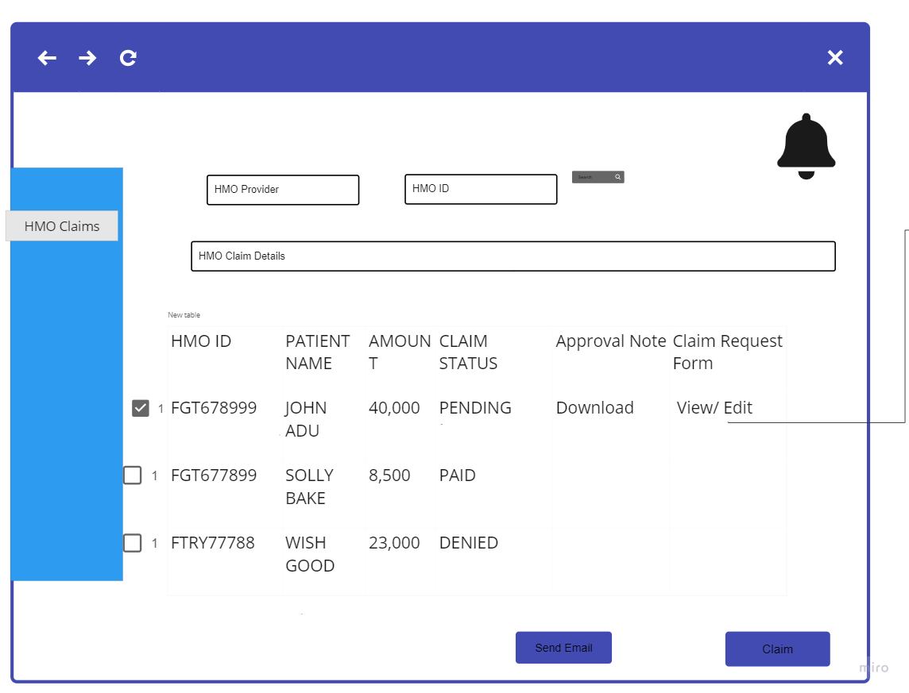

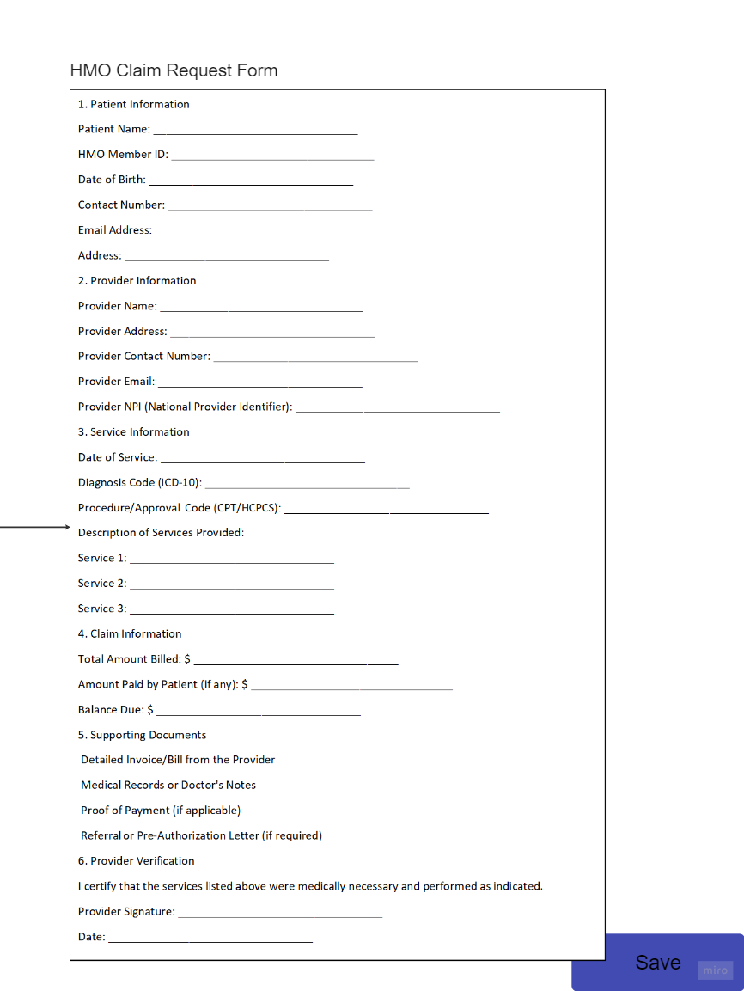

1. Wallet Management System
   1. Patient Wallet
      1. Upon Registering as a patient, the system should
         1. Create a wallet for Patient
         2. On click of wallet, the system should display
            1. Wallet Balance

System should check Transaction ref table to display the balance (Sum of amount credited minus debited amount) with the unique ID if any payment has been made.

System displays the amount balance in the wallet

* + - * 1. Fund wallet

Click should direct the patient to the following

Fund Via Card

Replicate same flow as we have on web payment gateway and credit the wallet of the hospital.

If successful system should credit the amount to user wallet

If failed system should Display an error

Fund Via POS

Replicate same flow as we have on web payment gateway and credit the wallet of the hospital.

If successful system should credit the amount to user wallet

If failed system should Display an error

* + - * 1. Fund via other channels (Transfer, bank)
        2. Wallet Transaction Details

On click should display the following

Transaction amount

Date of transaction

Transaction type (CR/ DR)

Invoice ID

Opening Balance

Closing Balance

1. **Refund Management**

Implement a wallet Refund management for patient on the HMS web portal solution

**1.2 Product Goal**

This product aims to develop a simplified refund management for patient in the case of dispute or mistake with full capability to verify the existence of patients, patient payment, the reason for refund and the refund status.

**1.3 USER SCREEN ACCESS AND PRIVILEGES**

|  |  |  |  |  |
| --- | --- | --- | --- | --- |
| **Portal** | **User Type** | **Screen/Menu Name** | **View** | **Add/Update/Delete** |
| Admin | Receptionist (Facility)  Accountant (Facility) | Refund Management🡪  Refund Application | yes | yes |
| Refund Review/ Approval | yes | No |
| Refund History | yes | No |
| Chief Accountant (Facility) | Refund application | yes | No |
| Refund Review/Approval | Yes |
| Refund History | No |
| Super Admin | Head of ICTA | Manage all Refund Management | yes | No |

* 1. System should display the Refund management sub-menu as follows:
     + 1. Refund Application
       2. Refund Review/Approval
       3. Refund History

1. **User Story** 
   1. Receptionist
      1. User should be able to apply for a refund for patient
      2. User should be able to view the approval status of refund
      3. User should be able to view refund history
   2. Accountant
      1. User should be able to apply for refund for patient
      2. User should be able to view approval status of refund
      3. User should be able to view refund history
   3. Chief Accountant
      1. User should be able to view the refund applicant
      2. User should be able to approve or disapprove applicant (patient) for refund
      3. User should be able to view approval status of refund
      4. User should be able to view refund history
2. **User journey** 
   1. **Refund Application** 
      1. On click of ‘Refund Application’ system should display the list of patient bill in a table format showing details as follows:
         1. Patient file number
         2. Patient name
         3. Bill date
         4. Invoice Number
         5. Transaction ID
         6. Item name
         7. Total bill amount
         8. Total Amount Paid
         9. Apply for refund
         10. Status
             1. Submitted
             2. Approved
             3. Disapprove
             4. Partially Approved
             5. Paid
         11. Action (Edit, Delete)

* + 1. On click of ‘Apply for Refund’ system should display a page in form format for the user to fill the following details:
       1. Bill amount (Auto fill)
       2. Item name (Auto fill)
       3. Amount to refund (amount must not be more than Bill amount)
       4. Total (amount should sum up and not be more than Bill amount)
       5. Patient account details (input box) (editable)
          1. Bank name (list of value)
          2. Account number
          3. Account name
       6. Comment box (compulsory)
       7. Forward Request Button (should only be active when applicant fills reason in the comment box)
          1. On click of ‘Forward Request’ system should send a notification to the ‘Chief Accountant’ and save the refund application on the ‘Refund Review/Approval’ table.
  1. **Refund Review/Approval** 
     1. On click of ‘Refund Review/Approval’ system should display the list of refund applicants as the following
        1. Patient File Number
        2. Patient Name
        3. Item name
        4. Bill amount
        5. Amount to refund
        6. Creation Date
        7. Status (system should update status based on action carried out)
           1. Approved
           2. Disapprove
           3. Partial Approval/ Review
        8. Total Payout ()
        9. Pay out Button (active for only approved/partially approved applicants)
           1. On click of ‘Payout Button’ system should display a message 🡪 confirm you want to refund this patient (name) (Yes/ No )
           2. On click of ‘Yes’ system should display the applicant details for refund

Account details (not editable)

Bank name

Account number

Account name

Pay

User should enter Mpin for the account, Receive via SMS/ Email.

System should display successful and exit.

Note: status should change on the apply for refund page

* 1. **Refund History** 
     1. On click of ‘Refund History’ system should display the refund list of applicants (patient) in a table format
     2. The details are as follows:
        1. Patient Name
        2. Bill Amount
        3. Item Name
        4. Refund Amount
        5. Creation Date
        6. Status (LOV)